Supplementary Material for
Hydrogen permeability prediction in palladium alloys and virtual screening of B2-phase stabilized ${Pd}_{(100-x-y)}{Cu}_{x}M_{y}$ ternary alloys using machine learning

1. Variables univariate distribution
The univariate distribution of the experimental variables is shown in Fig. S1.
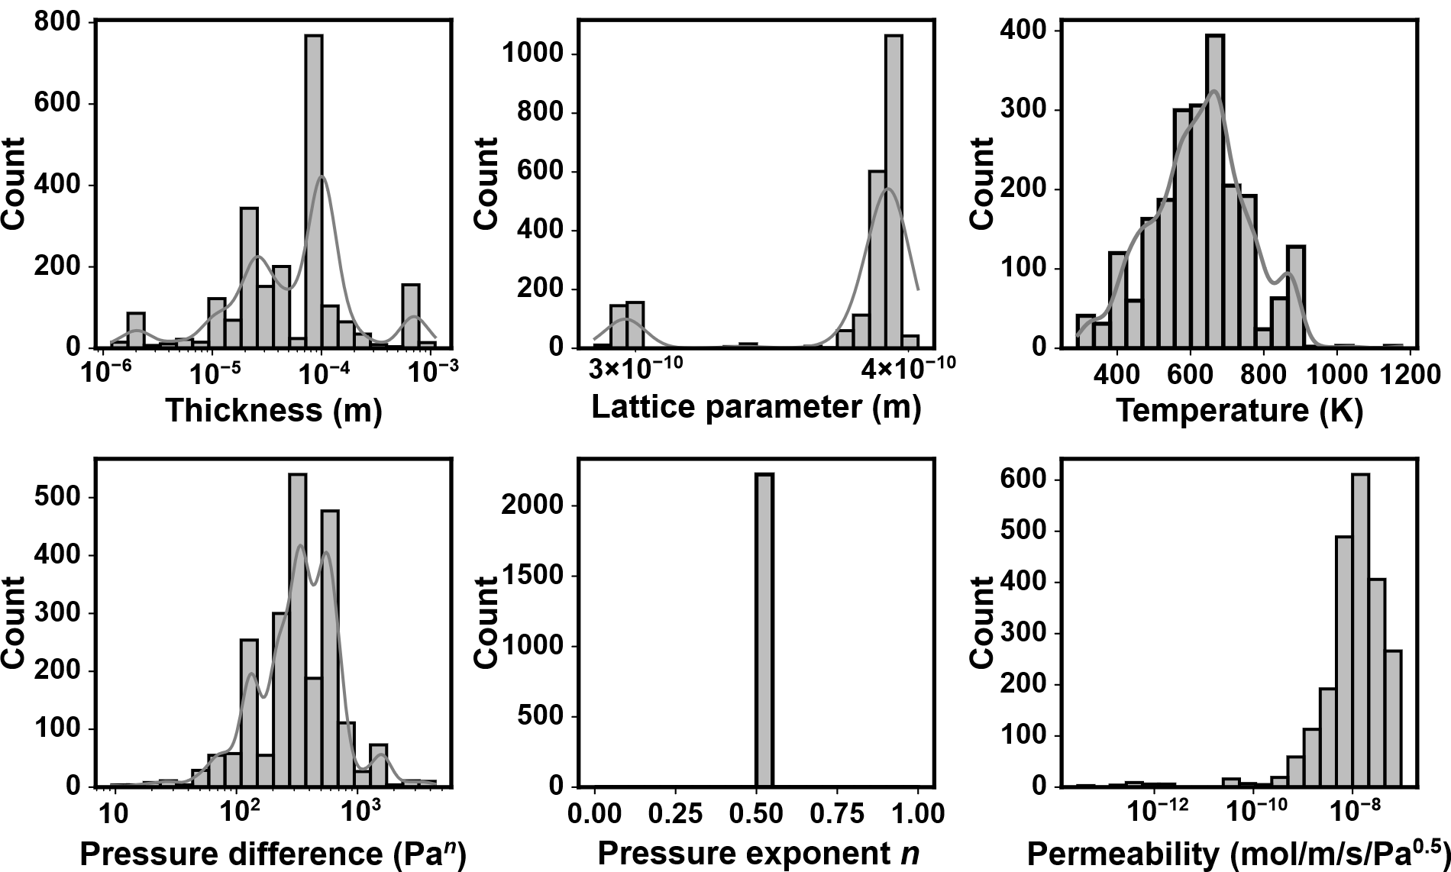
Fig. S1. Univariate distribution of the experimental data including (a) thickness, (b) lattice parameter, (c) temperature, (d) pressure difference, (e) pressure exponent, and the target variable (f) permeability.

2. Description of the features used in this work
This work used experimental variables (Fig. S1) and descriptors calculated based on alloy composition as material representation for machine learning. We refer to bond properties a.k.a Bond as domain-knowledge descriptors describing alloys phase formation rules; composition-based feature vector a.k.a CBFV as properties calculated using rule of mixtures; and fractional a.k.a Elemental as the element fraction representation. Table S1 summarizes the exhaustive list of descriptors included in each category.
Table S1. Description of features used for machine learning
Feature | Abbreviation | List | Reference
Experimental | Exp | thickness, temperature, pressure difference, pressure exponent, lattice parameter $a_{ss}$, lattice misfit term $a_{ss}/a_{Pd} =(a_{alloy}-a_{Pd})/a_{Pd}$ | −
Bond properties | Bond | No. of Components, Atomic Size difference (δ), electronegativity difference (Δχ), mixing enthalpy (${∆H}_{mix}$), mixing entropy (ΔSmix), Omega (Ω), valence electron concentration (VEC), Melting Temperature $T_{m}$, Entropy-to-squared atomic size difference (Λ), gamma parameter γ, Mean Cohesive Energy, local size mismatch (D⋅r), mismatch of local electronegativity (D⋅χ), shear modulus (G), modulus mismatch in strengthening model (η), difference of shear modulus δG, local modulus mismatch D⋅G, mean atomic packing efficiency (Mean APE) | [1–6]
Composition-Based Feature Vector | CBFV | avg_Atomic weight, avg_Atomic number, avg_Period, avg_Group, avg_Quantum number ℓ,  avg_Metal(1)/metalloid(2)/nonmetal(3), avg_Mendeleev_number, avg_Families, avg_Valence_s,  avg_Valence_p, avg_Valence_d, avg_Valence_f, avg_Unfilled_s, avg_Unfilled_p,  avg_Unfilled_d, avg_Unfilled_f, avg_No. of valence electrons, avg_Outer shell electrons,  avg_Gilman no. of valence electrons, avg_Metallic valence, avg_Zeff, avg_Ionization energy, avg_Electron affinity, avg_Pauling EN, avg_Martynov Batsanov EN, avg_Mulliken EN, avg_Allred EN, avg_Allred Rockow EN, avg_Nagle EN, avg_Ghosh EN, avg_Atomic radius calculated, avg_Covalent radius, avg_Effective ionic radius, avg_Miracle radius, avg_van der Waals radius, avg_Slater radius, avg_Pauling, R(CN12), avg_Pauling, R(1), avg_Polarizability, avg_Boiling point, avg_Density, avg_Specific heat, avg_Heat of fusion, avg_Heat of vaporization, avg_Heat of atomization, avg_Thermal conductivity, avg_Thermal expansion, avg_Cohesive energy, avg_Bulk modulus, avg_Shear modulus, avg_Young's modulus, avg_Hardness Vickers, avg_Hardness Brinell,  avg_Resistivity, avg_Electrical Conductivity, avg_DFT LDA Etot, avg_DFT LDA Ekin, avg_DFT LDA Ecoul, avg_DFT LDA Eenuc, avg_DFT LDA Exc, avg_DFT LSD Etot, avg_DFT LSD Ekin, avg_DFT LSD Ecoul,  avg_DFT LSD Eenuc, avg_DFT LSD Exc, avg_DFT RLDA Etot, avg_DFT RLDA Ekin, avg_DFT RLDA Ecoul, avg_DFT RLDA Eenuc, avg_DFT RLDA Exc, avg_DFT ScRLDA Etot, avg_DFT ScRLDA Ekin, avg_DFT ScRLDA Ecoul, avg_DFT ScRLDA Eenuc, avg_DFT ScRLDA Exc | [7,8]
Fractional | Elemental | B, Al, Ti, V, Cr, Mn, Fe, Co, Ni, Cu, Zn, Ga, Y, Zr, Nb, Mo, Ru, Rh, Pd, Ag, In, Sn, La, Ce, Pr, Sm, Gd, Tb, Dy, Ho, Er, Tm, Yb, Lu, Ta, W, Ir, Pt, Au, Pb | −

3. Data scaling
Although gradient-boosted decision tree algorithms such as CatBoost generally do not require any feature scaling —since they learn from the raw feature distributions— we applied robust scaling (Equation S1) using the RobustScaler function from the Scikit-learn package to mitigate potential effect of large feature magnitudes and outliers. Scaling parameters were fit on the training partition only and applied to the validation and test sets to prevent data leakage. For each feature $j$:
$x_{j}^{'}= \frac{x_{j}- {median}_{train}(x_{j})}{{IQR}_{train}(x_{j})}$ (Eq. S1)
Where $x_{j}$ is the original value of feature j, $x_{j}^{'}$ the scaled value, and $IQR= Q_{3 }- Q_{1}$ is the interquartile range, defined as the difference between the third quartile (75th percentile, Q₃) and the first quartile (25th percentile or Q₁) of the feature distribution computed on the training set.
4. Model evaluation
We assessed prediction performance using mean absolute error (MAE), root mean squared error (RMSE) and coefficient of determination R², all reported on the original permeability scale (mol·m⁻¹·s⁻¹·Pa^{-0.5}). MAE summarizes average absolute error and is less sensitive to extreme values; RMSE emphasizes large deviations; R² quantifies explained variance.
$MAE= \frac{1}{n}\sum_{i=1}^{n}{\left|y_{i}-{\hat{y}}_{i}\right|}$ (Eq. S2)
$RMSE= \sqrt{\frac{\sum_{i=1}^{n}{{\left(y_{i}-{\hat{y}}_{i}\right)}^{2}}}{n}}$ (Eq. S3)
$R^{2}=1- \frac{\sum_{i=1}^{n}{{\left(y_{i}-{\hat{y}}_{i}\right)}^{2}}}{\sum_{i=1}^{n}{{\left(y_{i}-\overline{y}\right)}^{2}}}=1- \frac{SSR}{SST}$ (Eq. S4)
where $y_{i}$ are true values, ${\hat{y}}_{i}$ predictions, $\overline{y}$ the sample mean, and $n$ the number of samples. MAE and RMSE share the target’s physical units, aiding interpretation. During training we optimized RMSE in CatBoost (GPU-supported, differentiable); MAE and $R^{2}$ were computed for reporting. Lower MAE/RMSE and higher $R^{2}$ indicate better performance.

5. Pearson correlation filtering
Redundant descriptors were removed using the absolute Pearson correlation threshold $\left|r\right|≥0.90$. The Pearson coefficient is given by Equation S5:
$r= \frac{\sum_{i=1}^{n}{{(x}_{i}-\overline{x})(y_{i}-\overline{y})}}{\sqrt{\sum_{i=1}^{n}{{(x_{i}-\overline{x})}^{2}}}\sqrt{\sum_{i=1}^{n}{{(y_{i}-\overline{y})}^{2}}}}$ (Eq. S5)
where $x_{i}$ and $y_{i}$ are the $i$-th sample values of two features, and $\overline{x}$, $\overline{y}$ are their means.
When a pair satisfied this condition, the kept descriptor was chosen by domain knowledge, prioritizing properties historically linked to hydrogen permeability. The external test set remained untouched.
For each feature set, we computed the Pearson correlation coefficients to measure the pairwise linear correlation between pairs of features. To prevent data leakage, we only applied the filtering measure to the training set. Due to many correlation thresholds proposed in the literature (typically in the range 0.85−0.95) [9,10], we arbitrarily adopted $\left|r\right|≥0.90$ to prevent aggressive cast out. We phased out less domain-grounded descriptors using the defined filter. Herein we summarize the feature removal process.
Within the Exp_Bond descriptor set, we retain the lattice misfit $∆a_{ss}/a_{Pd}$ instead of Lattice parameter since Pd was used as a reference. We found a perfect linear correlation between the two variables $\left|r\right|=1$.0. Similarly, correlated with $\left|r\right|=0.90$, we selected the atomic size difference ($δ$) and discarded the $γ$ parameter. We empirically introduced $∆H_{mix}/∆$ because $∆H_{mix}$ and $∆$ are strongly correlated ($r$=-0.91) and, further $∆$ is strongly correlated with other features. $∆H_{mix}/∆$ was found to have a linear correlation below the define thresholds with the remaining descriptors. We have also kept the difference of shear modulus $δG$ instead of the local modulus mismatch $D∙G$ ($r$=0.94) since the former it easier to compute. The newly built uncorrelated set that with labelled ‘Exp_Bond_uncorr’ possesses 23 features due to keeping $∆H_{mix}/∆$ and $∆H_{mix}$ together. The latter two descriptors have a pairwise r = 0.08. The correlation heatmap of ‘Exp_Bond_uncorr’ is given in Fig. S2.
From Exp_Elemental descriptor set, we only drop Lattice parameter and kept $∆a_{ss}/a_{Pd}$ yielding a 44-dimensions feature set. Note that although zero-variance elemental column might be present in Exp_Elemental training set (i.e. if an element in the test set is absent from the training set), we refrain from removing them and acknowledge that no learnable pattern is extractable from a zero-variance feature.
In Exp_CBFV all DFT-related features were removed due very strong pairwise linear correlations. The remaining features are examined on a case-per-case basis, depending upon their assumed historical correlation to H₂ occlusion in metals (refer to code accompanying this work for details, at https://github.com/AldoKwamibar/Pd-membranes-permeability). We obtained a newly ‘Exp_CBFV_uncorr’ with 27 features.
The three uncorrelated pairs of feature set were used to build pristine triplet and quartet feature set combinations following the same protocol described earlier.
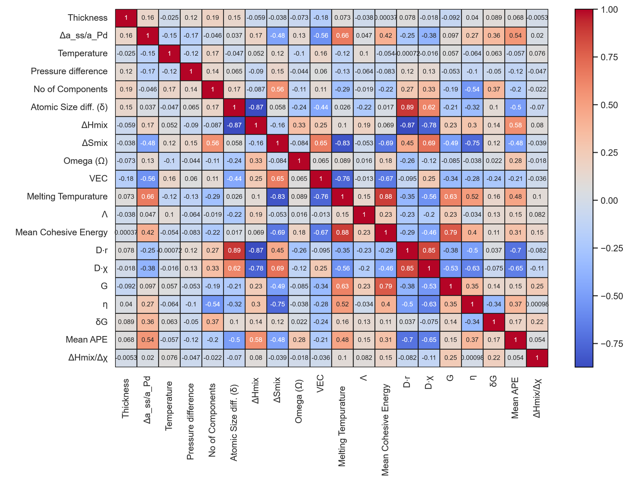
Fig. S2. Pearson correlation of the newly formed uncorrelated Exp_Bond. No value was rounded. This allows to consider a Pearson correlation coefficient of $\left|r\right|<0.89$ as being strictly below the threshold $\left|r\right|=0.90$.
7. SHapley Additive exPlanation (SHAP)
SHapley Additive exPlanations (SHAP) is a model-agnostic interpretability framework based on cooperative game theory that attributes to each feature a quantitative Shapley value, representing its contribution to a model output. These values decompose a prediction into additive feature effects, indicating how individual features shift the output relative to the baseline (the expected model prediction). SHAP can thus provide local explanations as well as global explanations. In this study, we employed the gradient-boosted decision tree-specific implementation, TreeSHAP, which efficiently computes exact Shapley values for ensemble tree models [11].
8. Hyperparameter tuning
We implemented a CPU-based bespoke randomized optimal hyperparameters search with early-stopping (patience = 20) and MAE minimization on the validation folds used to pick the best hyperparameters. RMSE was maintained as the default loss function of the CatBoost regressor. We tuned the four most important hyperparameters suggested in CatBoost documentation: the learning rate, the trees depth, and overfitting controlling terms, viz. the L2 regularization of the leaf values of the decision tress, and the amount of randomness during split selection.
9. Origin of negative R² for 95/15 split: variance calculation
In this section, we demonstrate that the negative R² score observed in the test prediction of a 95/15 split is due to small variance in the permeability distribution. To confirm such observations, we computed the standard deviation (STD), the variance (VAR), and the interquartile range (IQR), and the total sum of square SST terms (Eq. S4). The 95/15 test target variable has three times smaller spread (STD) compared to 85/15, and approximately 1.4 orders of magnitude lower SST. Table S3 compares the STD, VAR, IQR and SST for 80/20, 85/15 and 95/5.
Table S2. Standard deviation (STD), interquartile range (IQR), and total sum of squares (SST) across the test sets.
Size | STD | VAR | IQR | SST
80/20 | 2.26×10⁻⁸ | 5.12×10⁻¹⁶ | 2.62×10⁻⁸ | 2.22×10⁻¹³
85/15 | 2.15×10⁻⁸ | 4.64×10⁻¹⁶ | 2.89×10⁻⁸ | 1.57×10⁻¹³
95/5 | 6.74×10⁹ | 4.55×10⁻¹⁷ | 8.54×10⁻⁹ | 5.91×10⁻¹⁵

10. Confidence interval
Uncertainty for MAE, RMSE, and $R^{2}$ was estimated by block bootstrap of the held-out test predictions, readapting methods suggested by Sanchez-Lengeling et al. and Raschka [12,13]. Blocks were defined as alloy formulas. For 50,000 replicates we resampled blocks with replacement, recomputed the metrics, and summarized their empirical distributions. We report the bootstrap mean, standard error, and 95% percentile intervals (2.5th to 97.5th). Figure S3 presents graphic visualization of bootstrap of test set predictions.
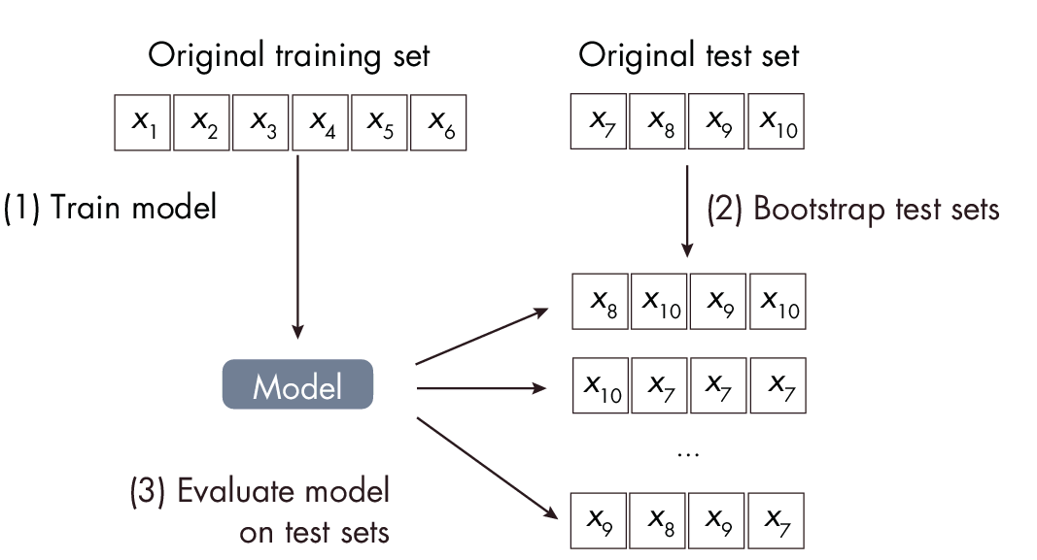
Fig. S3. Illustration of bootstrap of the test set predictions [12]. In our work X_{i} represents groups of mutual exclusive formulas (blocks). The model is trained once.
11. Miedema enthalpy of formation
We calculated the enthalpy of formation of the virtual Pd−Cu−M solid solutions as function of the solute concentration and summarize the results in Fig. S4. The calculation was implemented using Miedema featurizer from the Matminer package [3]. Most trends obtained here are similar to those found using DFT by Gao et al. [14].
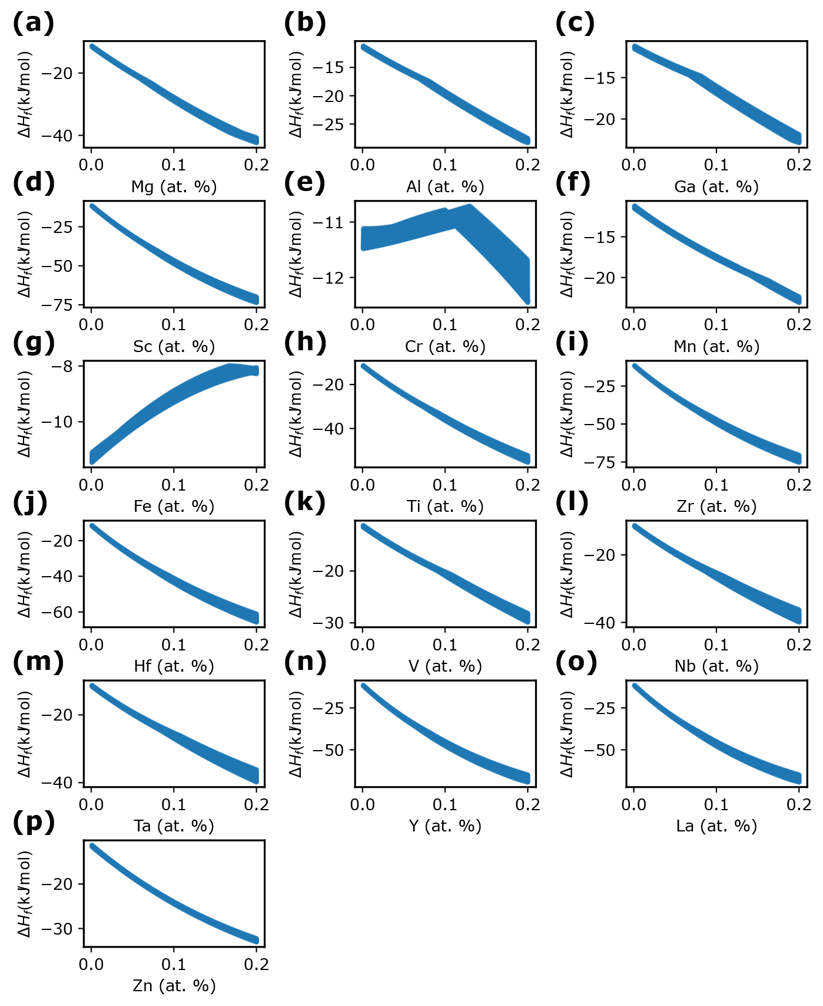
Fig. S4. (a)−(p) Enthalpy of formation of Pd−Cu−M as function of M content. The enthalpy is calculated using Miedema semi empirical model as implemented in Matminer material informatics package [3].
12. Solute miscibility in Pd
To propose alloy candidates for experimental validation we obtained the range of miscibility of M solute in Pd−M binary solid solution. We assume that, there will not be a miscibility gap if the concentration of M in the ternary alloy is within the limits of the concentrations that allows Pd-rich solid solution formation in binary Pd−M without alteration of Pd structure. The values summarized in Table S3 are derived from ASM International Alloy Phase Diagram Handbook and the literature.
Table S3. Range of concentration of M in Pd−M solid solution. The concentrations reported are within the limit of that which preserve FCC structure of Pd (cF4, Fm$\overline{3}$m)
Solute | Concentration (wt.%) | Structure of Pd
Al | (Pd) 94 to 100 | cF4, Fm$\overline{3}$m
Cr | (Pd) ∼67 to 100 | cF4, Fm$\overline{3}$m
(γFe, Pd) | (Pd) 93-100 Fe | cF4, Fm$\overline{3}$m
Ga | (Pd) very small conc. of Ga | cF4, Fm$\overline{3}$m
Nb | (Pd) 73 to 100 | cF4, Fm$\overline{3}$m
Ti | (Pd) 93 to 100 | cF4, Fm$\overline{3}$m
V | (Pd) 0 to 40 V in Pd | cF4, Fm$\overline{3}$m
Y | (Pd) 0-11 of Y in Pd | cF4, Fm$\overline{3}$m
Zn | (Pd) 0 to 13 of Zn in Pd | cF4, Fm$\overline{3}$m
Cr | (Pd) ∼67 to 100 | cF4, Fm$\overline{3}$m
Mg [15] | (Pd) 75-100; 0-20 of Mg in Pd | cF4, Fm$\overline{3}$m
Ta [16] | (Pa) 100-82; 0-18 of Ta in Pd | cF4, Fm$\overline{3}$m
Hf | (Pd) 0-20% of Hf in Pd | cF4, Fm$\overline{3}$m
Sc | (Pd) 0-10% of Sc Pd | cF4, Fm$\overline{3}$m
Zr | (Pd) 0-12 of Zr in Pd | cF4, Fm$\overline{3}$m

Reference
[1] S. Guo, Phase selection rules for cast high entropy alloys: An overview, Mater. Sci. Technol. 31 (2015) 1223–1230. https://doi.org/10.1179/1743284715Y.0000000018.
[2] E. Magnone, M.C. Shin, J.I. Lee, J.H. Park, Relationship between hydrogen permeability and the physical-chemical characteristics of metal alloy membranes, J. Membr. Sci. 674 (2023) 121513. https://doi.org/10.1016/j.memsci.2023.121513.
[3] L. Ward, A. Dunn, A. Faghaninia, N.E.R. Zimmermann, S. Bajaj, Q. Wang, J. Montoya, J. Chen, K. Bystrom, M. Dylla, K. Chard, M. Asta, K.A. Persson, G.J. Snyder, I. Foster, A. Jain, Matminer: An open source toolkit for materials data mining, Comput. Mater. Sci. 152 (2018) 60–69. https://doi.org/10.1016/j.commatsci.2018.05.018.
[4] C. Wen, Y. Zhang, C. Wang, D. Xue, Y. Bai, S. Antonov, L. Dai, T. Lookman, Y. Su, Machine learning assisted design of high entropy alloys with desired property, Acta Mater. 170 (2019) 109–117. https://doi.org/10.1016/j.actamat.2019.03.010.
[5] E. Yan, L. Tao, K. Zhang, H. Chen, G. Huang, J. Bai, Y. Li, K. Liao, Y. Zou, H. Zhang, L. Sun, A new strategy for designing Nb-based H2-selective alloys based on physical-chemical parameter matching rules, J. Mater. Res. Technol. 38 (2025) 2782–2793. https://doi.org/10.1016/j.jmrt.2025.08.125.
[6] X. Yang, Y. Zhang, Prediction of high-entropy stabilized solid-solution in multi-component alloys, Mater. Chem. Phys. 132 (2012) 233–238. https://doi.org/10.1016/j.matchemphys.2011.11.021.
[7] S. Kauwe, A. Wang, A. Falkowski, CBFV: Tool for quickly creating a composition-based feature vector, (2021). https://github.com/Kaaiian/CBFV.
[8] S. Lee, C. Chen, G. Garcia, A. Oliynyk, Machine learning descriptors in materials chemistry used in multiple experimentally validated studies: Oliynyk elemental property dataset, Data Brief 53 (2024) 110178. https://doi.org/10.1016/j.dib.2024.110178.
[9] J. Gong, S. Chu, R.K. Mehta, A.J.H. McGaughey, XGBoost model for electrocaloric temperature change prediction in ceramics, Npj Comput. Mater. 8 (2022) 140. https://doi.org/10.1038/s41524-022-00826-3.
[10] J. Zhang, B. Xu, Y. Xiong, S. Ma, Z. Wang, Z. Wu, S. Zhao, Design high-entropy carbide ceramics from machine learning, Npj Comput. Mater. 8 (2022) 5. https://doi.org/10.1038/s41524-021-00678-3.
[11] S.M. Lundberg, G. Erion, H. Chen, A. DeGrave, J.M. Prutkin, B. Nair, R. Katz, J. Himmelfarb, N. Bansal, S.-I. Lee, From local explanations to global understanding with explainable AI for trees, Nat. Mach. Intell. 2 (2020) 56–67. https://doi.org/10.1038/s42256-019-0138-9.
[12] S. Raschka, Chapter 25: Confidence Intervals, in: Mach. Learn. Q AI 30 Essent. Quest. Answ. Mach. Learn. AI, No Starch Press, 2024. https://sebastianraschka.com/books/ml-q-and-ai/.
[13] B. Sanchez-Lengeling, J.N. Wei, B.K. Lee, R.C. Gerkin, A. Aspuru-Guzik, A.B. Wiltschko, Machine Learning for Scent: Learning Generalizable Perceptual Representations of Small Molecules, (2019). https://doi.org/10.48550/ARXIV.1910.10685.
[14] M.C. Gao, L. Ouyang, Ö.N. Doğan, First principles screening of B2 stabilizers in CuPd-based hydrogen separation membranes: (1) Substitution for Pd, J. Alloys Compd. 574 (2013) 368–376. https://doi.org/10.1016/j.jallcom.2013.05.126.
[15] H. Okamoto, Mg-Pd (Magnesium-Palladium), J. Phase Equilibria Diffus. 31 (2010) 407–408. https://doi.org/10.1007/s11669-010-9732-6.
[16] H. Okamoto, Pd-Ta (Palladium-Tantalum), J. Phase Equilibria Diffus. 28 (2007) 233–233. https://doi.org/10.1007/s11669-007-9041-x.

